**1. INDRODUCTION:**

**IDENTIFING PATTERNS AND TRENDS IN CAMPUS PLACEMENT DATA USING MACHINE LEARNING**

**1.1**Overview:

It refers to recruitment from educational institutions. Some big organizations remain in touch with the colleges, universities, management institutes, etc.

1.2Purpose:

* Recruiting is a program conducted within universities or other educational institutions to provide jobs to students nearing completion of their studies.
* In this type of program, the educational institutions partner with corporations who wish to recruit from the student population.

**2. PROBLEM DEFINITION & DEISIGN THINKING:**

2.1 Empathy map:

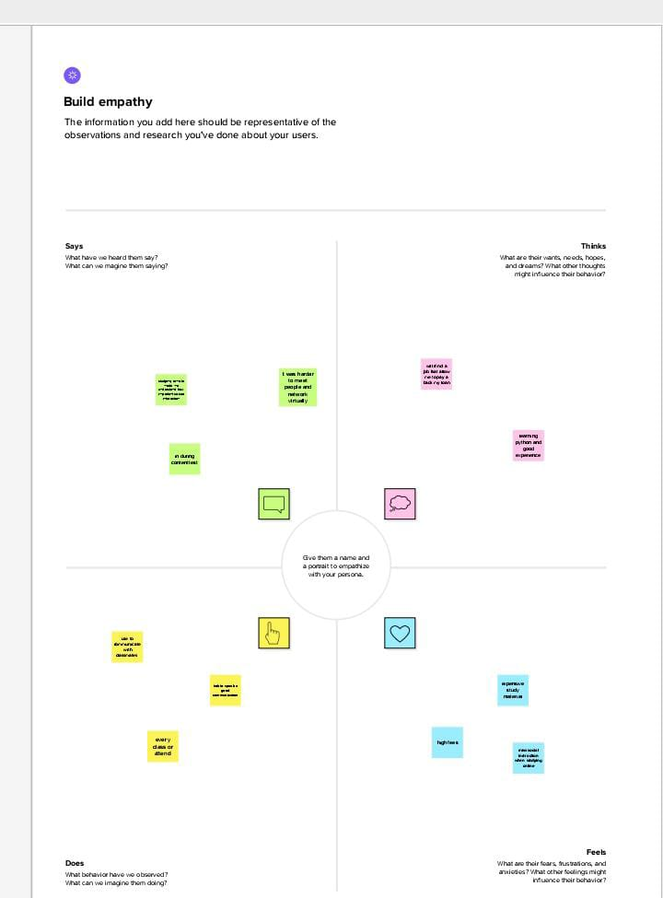

**3. RESULT:**

**4. ADVANTAGE DISADVANTAGE:**

* 1. Advantage:
* Main advantage of campus placement is that it is possible for companies to select quality candidates with in short time duration.
* Campus recruitment helps in increased selection ratio. More number of quality candidates can be selected through this recruitment process.
  1. Disadvantage:
* Campus requirement is on expensive affair for majority of the companies as it adds up costs to the bottom line.
* Companies incur different expenses related to travel, boarding, training etc.., while conducting campus selection process.
* Also, students can’t work with their dream company and will have to remain satisfied with the company that recruits them during campus selection.

**5. APPLICATIONS:**

* **Making the right career decision and communicating effectively at each step of the job ion process.**
* **No preview campus placements as we known today is a process involving interview of college students by recruiting companies utilizing institutional resources towards candidate j**
* **ob selection.**

**6. CONCULUSION:**

* End of the placement evaluation from and feedback
* Goals for future placement
* Performance of students

**7. FUTURE SCOPE**

* As per India Skills Report 2019, Electronic and Communication Engineering & Information Technology have the highest employability rate.
* There will be an increase in the demand for management and ITI graduates.